1. 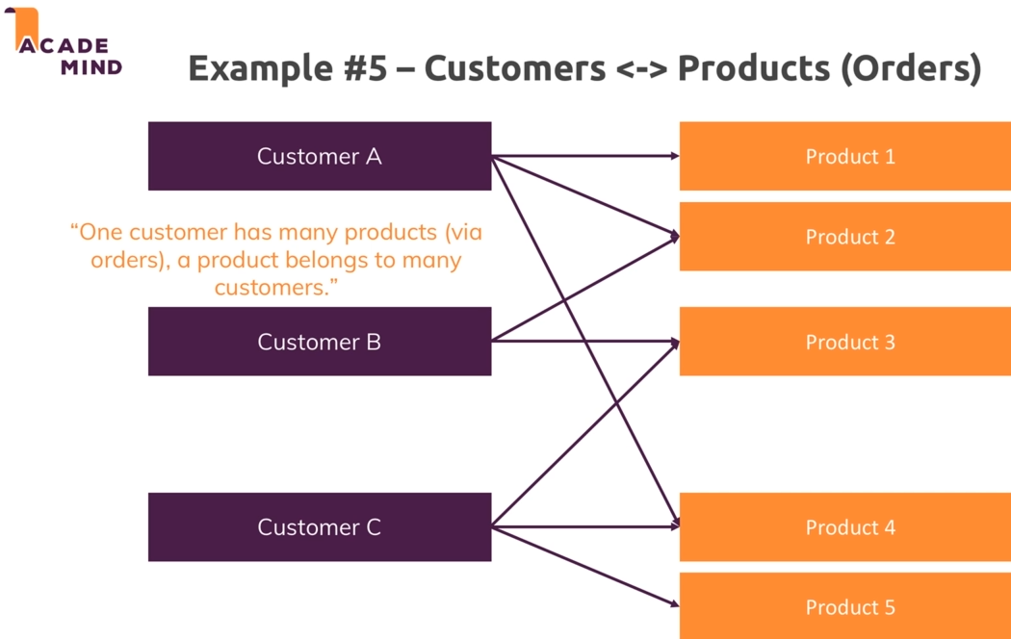
2. 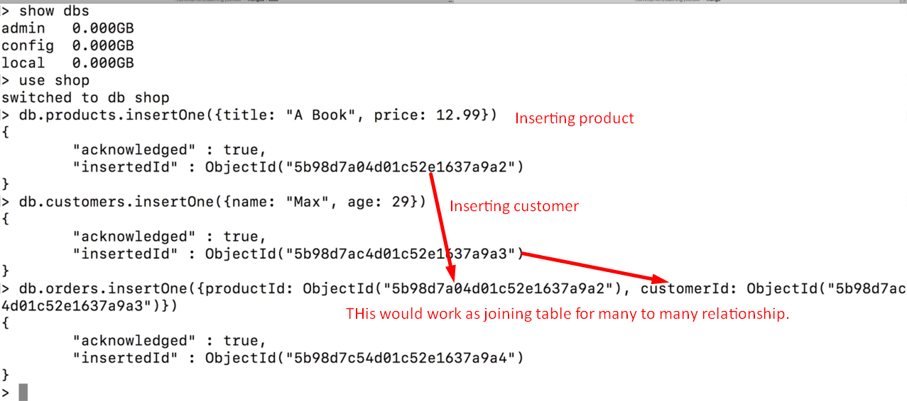
3. 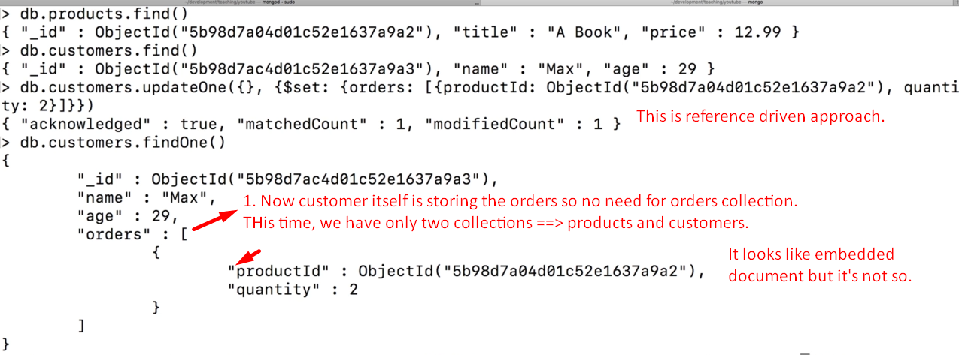
4. 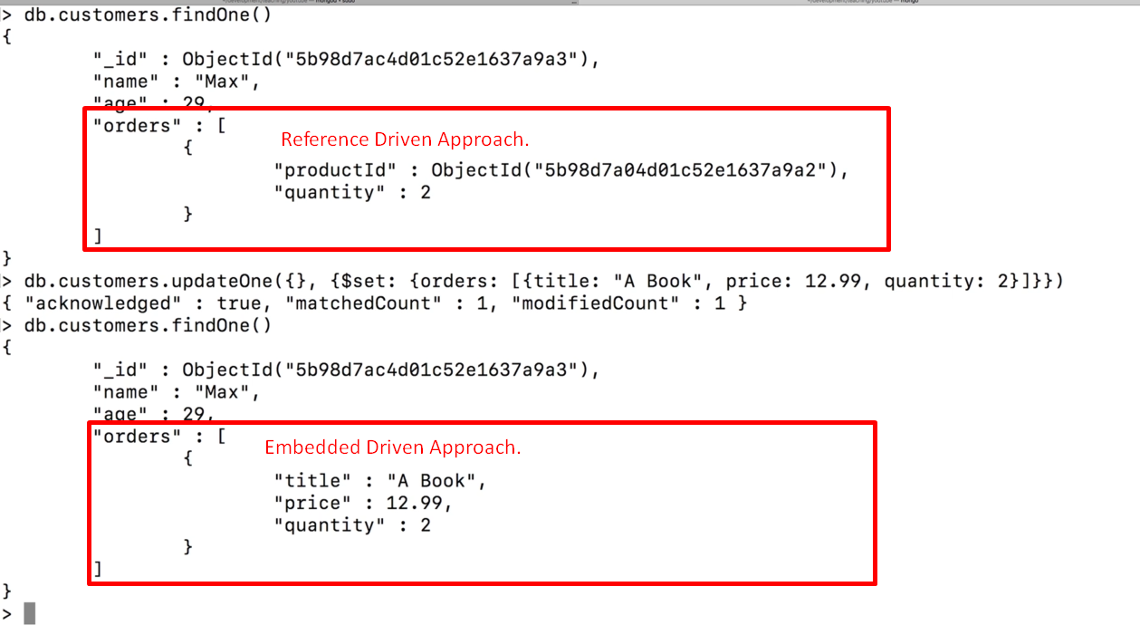  
   Embedded Approach Disadvantage: Duplicating data such as title and price each time when this product is order.  
   Second, you need to change data everywhere it’s being duplicated.